C o n f i d e n t i a l
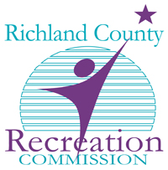 | Richland County Recreation Commission Public and Employee Safety  Video Request Form

This form must be completed and sent to the Public and Employee Safety Department by inter-office mail or by e-mail to Robert@rcrc.state.sc.us

Current Date: Date of Incident:

Individual Submitting Video Request: Title:

Phone: E-Mail:

Dept. or Division Name:

Law Enforcement Case Number (Required):

Reason (s) for Need (Limited to incidents accompanied by a police report):

Date: To Date:

Time: To Time:

Location:

Director or Manager Signature: Date:

SAFETY DEPARTMENT VERIFICATION:

Date received: Approved Denied: Reason:

Signature: Date:

